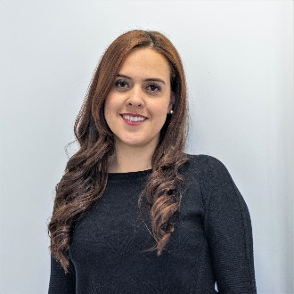

* Name: Mónica Cala
* E-mail: [mp.cala10@uniandes.edu.co](mailto:mp.cala10@uniandes.edu.co) – [metcore@uniandes.edu.co](mailto:metcore@uniandes.edu.co)
* Bio: Mónica Cala is currently the Head of Metabolomics Core Facility – MetCore at Universidad de los Andes in Bogotá, Colombia. She obtained her PhD in Chemical Sciences at Universidad de los Andes in 2017. She has extensive experience in Analytical Chemistry, particularly in separation techniques such as gas chromatography (GC), liquid chromatography (LC) and capillary electrophoresis (CE) coupled with high-resolution mass spectrometry. Since 2012, She has been working in the application of analytical tools in non-targeted metabolomics based on mass spectrometry, particularly in biomedical applications, performing non-targeted metabolomics multiplatform by GC-MS, LC-MS and CE-MS. At Metcore, she is currently leading research projects applying non-targeted and targeted metabolomics in different areas such as health, nutrition and agriculture.